ECSE 425 – Computer Organization and Architecture
Software Simulation of Branch Prediction Strategies

Simon Foucher (260 223 197)

Stefanos Koskinas (260 211 145)

April 2nd, 2009

1. Hardware Simulated

Software flow
All four code files were designed using a similar architecture. When the software is ran, the main function opens a file pointer to the first trace, and passes it to the function readTrace, as well as the number of bits for the size of the predictor (if applicable). This function is called 10 times/trace, for 2-bit, 4-bit, …, 20-bit predictors.
Once in the readTrace function, the first step is to initialize and format the arrays. We also calculate two boundary variables named “Nmask” and “threshold”. Nmask = 2^n - 1 and serves as a maximum boundary for the predictor (the minimum boundary is always 0). Threshold = (Nmask + 1)/2 and serves as a predictor decision threshold. As a convention, low value predictors favor branch not taken. For example, on an 8 bit test, Nmask = 255, which is the maximum value that the predictor can take, and threshold is 128, meaning that if the predictor < 128, it predicts that the branch will be taken.
Afterwards, we fetch one line of data at a time from the trace file which got opened (hence the huge processing time due to massive I/O wait). The address is extracted and a lookup is made on the “addresses” array to see if it is the first time that this particular branch address is encountered. The array is scanned from index k = 0, until the system finds either a previous entry of that branch, or an empty spot on the array. If the entry is found, k is recorded and used as an index for selecting predictors. If the system encounters an empty spot on the array before finding a match, the address is recorded at that spot and the index k will now be associated with this branch for future occurrences.
Note: due to the memory address limitations of my 32-bit PC, I was not able to run the correlating predictor with the server trace file (required at least 10300 x 256 addresses) and constantly got segmentation fault. To counter this, a Boolean variable called “tooBig” was introduced to inform the predictor that it needed to “compress” the data if it was analyzing the server trace. In order to do so, the first two decimal bits of the addresses were ignored, which generated a decrease in performance for the server traces, since multiple addresses might have been sharing the same LSBs (least significant bits). The same scheme was used for every type of predictors on the server trace, therefore the data collected is still usable (we can adequately comment on the performance of different predictors, but we cannot compare server traces with INT traces, since the INT traces were fully indexed, whereas the server traces were indexed using a subset of address bits).
After extraction of the data and computation of index k, these parameters are fed to the predictors and statistical data is gathered based on whether a good prediction was made or not. At the same time, the predictors adjusted themselves to reflect the new branch outcome.
The predictors were implemented using different algorithms (described below). In order to interpret the prediction of a branch, if the predictor < threshold, the prediction is branch not taken, and if predictor > threshold, then we predict branch taken. Whether the prediction was right or wrong, the predictor got modified with accordance to the branch result (decremented for not taken and incremented for taken). The predictors were never decremented below 0 or above “Nmask”. Whenever a threshold was passed, the predictors jumped at the other edge of the prediction (see book p.83). For example, on a 3-bit predictor (Nmask = 7, threshold = 4, therefore 0-3 predict not taken and 4-7 predict taken), if the predictor was at 4 and the branch was not taken, the predictor was set to 0.

2. Predictor Algorithms

2.1 Static branch prediction policies
Code file: /code/static.c
Data collected: See Appendix II-A)

In order to analyze the result of a simple static prediction policy, the trace files were read and a basic statistical analysis was performed on the number of branched taken and not taken. This information is sufficient to discuss the implementation of a static always predict taken or not taken algorithm, since their performance are complementary.
For example, by knowing that 18% of branches were taken on the FP traces, we know that a “predict taken” mechanism would have a failure rate of 82%, whereas a “predict not taken” algorithm would result in a failure rate of 18%.

2.2 Branch prediction buffer (n-bit predictor)
Code file: /code/buffer.c
Data collected: See Appendix II-B

A branch prediction buffer was implemented and results were gathered for 2, 4, 8, …, 20-bit buffers. Due to the non-dynamic nature of this project, we were able to generate a unique predictor for every single branch address present on the trace files (see section 1.1 Software flow). After figuring out the branch index value (k), this value and the branch result were passed on to the predictor.
The predictor consists of an array of 10 000 integers called “predictorLocal”. The index k was used to select which predictor to use, and the integer present was used as a predictor. In order to minimize memory use, the predictors mimicked the behavior of binary strings, but were manipulated using integers. To demonstrate the methodology used we will use in this report (h) to imply hardware implementation and (s) for software implementation.
Here is the explanation of an 8-bit predictor. Here, Nmask = 255 and threshold = 128.
Range: (h) [0000 0000, 1111 1111] (s) [0, 255]
Range for predict not taken: (h) [0000 0000, 0000 1111] (s) [0, 127]
Range for predict taken: (h) [0001 0000, 1111 1111] (s) [128, 255]
After interpreting the predictor, the system read the branch result, and “totalGoodPredictions” (an integer keeping track of the number of good predictions) got incremented in the event of a good prediction. Also, the local predictor gets incremented in the event of a branch taken and decremented in the event of a branch not taken. As described in the book, whenever a threshold is reached, the predictor jumps to the other end of the scale.

For example:
Predictor value: (h) [0000 1111] (s) [127]
New value if branch Taken: (h) [1111 1111] (s) [255]
New value if branch not Taken (h) [0000 1110] (s) [126]
After these updates, the system fetches the next line of the trace and continues until the trace is done. All four traces are analyzed in this manner.

2.2 Correlating Predictor
Code file: /code/correlator.c
Data collected: See Appendix II-B

The correlating predictor uses similar predictors with one major modification. Every branch address has 256 local predictors. As above, once the branch address is known, the address array is scanned to see if there already exists a history for this branch. A slight modification had to be made for the server trace. Because of the large number of different branch addresses, the amount of memory allocated at run time to account for every single address caused a Heap/Stack collision and forced the OS (operating system) to terminate the process. To counter this, the variable “tooBig” was implemented to notify that the server address space was too big. In such a case, the two most significant digits of the branch address were ignored, which resulted in a reduced accuracy of predictions when evaluating the server traces.
The branch enters the predictor with an index k to select which predictor to choose. Once predictor[k] is selected, the globalPredictor is used to select among 256 local predictors for a single branch. If a good prediction is made, a counter is incremented to keep statistical data. Within the same thread, both the local predictor selected as well as the global predictors get updated (in the same manner described in section 2.1 Branch prediction buffer) to reflect the outcome of the branch.
This provides an extra advantage to the predictor, because the global history is used to reflect similar loops and counters encountered within a program.

2.3 Tournament predictor
Code file: /code/tournament.c
Data collected: See Appendix II-B

The tournament predictor implements both the buffer predictor and the correlating predictor. For every branch encountered, both predictors make a prediction based on their state in the same manner described above. In addition, a 2-bit history table is kept as a record of which predictor was the most accurate at the last iteration. The 2 bits of history are stored in an integer array called “chooser” and every branch address has its own history table. In the last few iterations, if the buffer predictor is more accurate, it is selected to make this prediction, and vice versa for the correlating predictor.
Once the outcome of the branch is known, the buffer predictor, local predictors and global predictors that are present within the correlating predictor get updated. Based on whether one of the two predictors was more accurate than the other, the history table associated with this particular branch also got updated to reflect this information.
For every address of every trace, statistical data was gathered based on the performance of the tournament predictor.

3. Results
The following table was built using the results gathered while running static.c (see Appendix II for raw data).
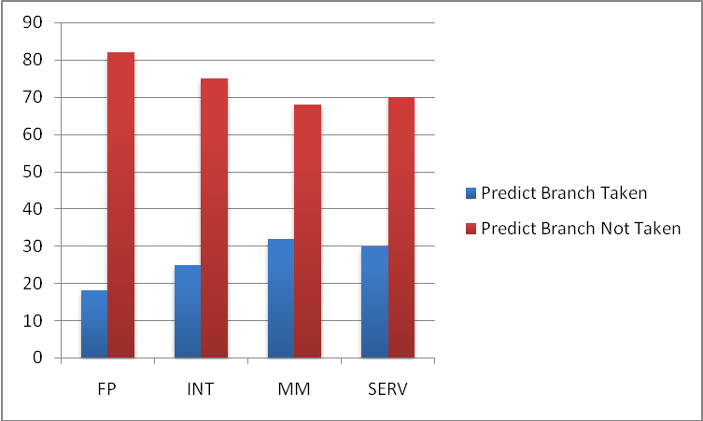
Figure 3.1: Success rate of a static Branch predictor. Predict taken in red, and predict not taken in blue.

From Figure 3.1, we can easily observe that for all 4 trace files, 68% to 82% of branches end up not being taken. This is coherent with what could be expected, since the purpose of loops is usually to repeat the same task many times until it is fully accomplished. This implies that branch conditions, when evaluated, will more often be not taken such that the loop’s body can be executed many times.
Based on this, the most efficient static branch prediction bias would be to predict that branches will not be taken. This would end up being right roughly ¾ of the time for general purpose processors. As further results demonstrate, there are better prediction schemes.

The following data shown in Figure 3.2 was gathered to compare all 3 “intelligent” branch prediction algorithms, i.e. branch prediction buffer, correlating predictor and tournament predictor.

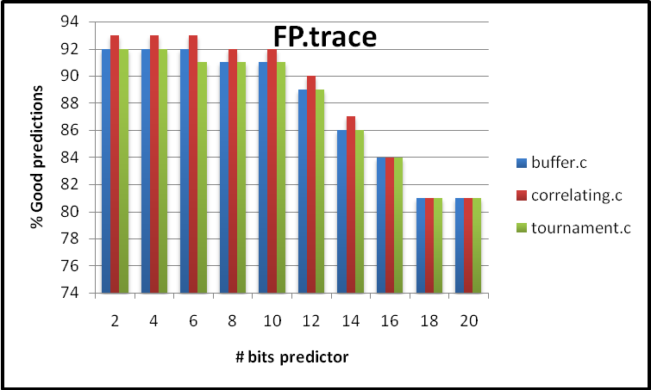
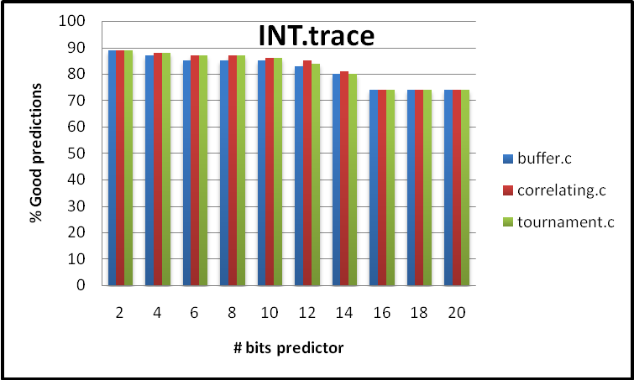

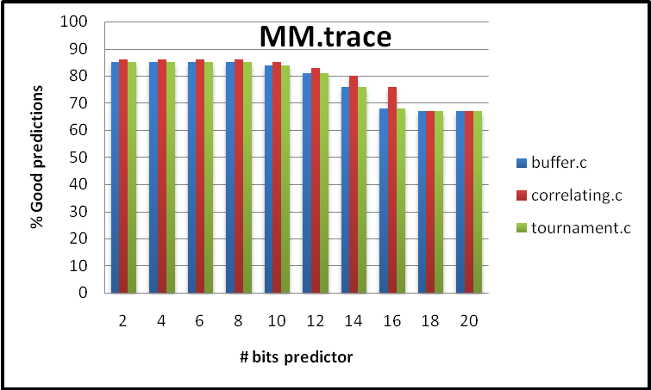
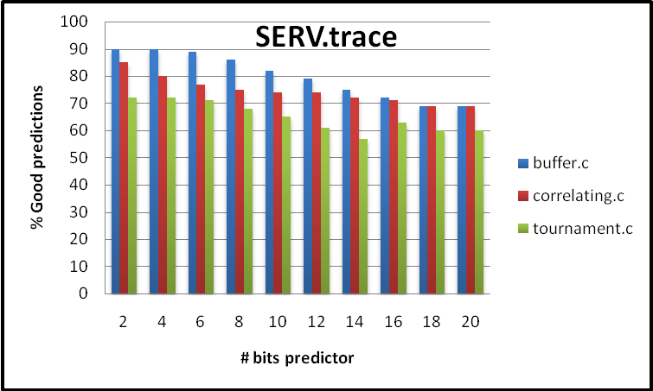
Figure 3.2: Comparing the different branch prediction algorithms using 4 trace files

From the data gathered, we can see that the optimal size for the prediction buffer is 2 bits. This is due to the fact that for larger bit size predictors, there needs to be many consecutive mistakes before the predictor changes its bias. By doing so, those predictors lose sensitivity and their performance decreases. This phenomenon is useful for the actual implementation, because a good performance from low-bit predictors reduces the quantity of hardware required.

Another observation is that, in general, the correlating predictors are better than the buffer predictors. This result was also expected since correlating predictors take advantage of global branch information. This information provides a way to choose from an array of local predictors, so different predictors can be selected to reflect different situations for every branch. The performance gap between buffer and correlating predictors was most accentuated in the FP trace.
We can also observe that for the FP trace, the tournament prediction was not more accurate than the correlating predictor. This is most probably due to the fact that operations were repeated many times and this was captured by the tournament choosing table. Floating point operations generally require many clock cycles, so the global predictor became a good way of capturing this regularity.
In the INT trace, the best prediction algorithm was the tournament predictor. This can be attributed to the fact that the tournament makes intelligent selections of predictors. Since there are a relatively small number of integer operations, the choosing table was efficient in allocating an adequate predictor for the branch operation at hand.
Another conclusion worth pointing out is that the performance of the tournament predictor in the SERV trace was lower. This is not necessarily due to a lack in performance of the predictor. As mentioned earlier, because of the chosen architecture, the branch address array was too large to be allocated enough memory for the server trace, which forced the implementation of a predictor that is less sensitive to changes in addresses. By conglomerating different addresses within the same predictors, the performance of the predictors was greatly decreased.
We can also observe the performance of the prediction schemes on a more global scale. To do so, we use the gathered data shown in Figure 3.2 and calculate the average performance of each prediction scheme for each trace. In addition, we calculate the average performance of each prediction scheme for all traces. The data is represented in Figure 3.3.

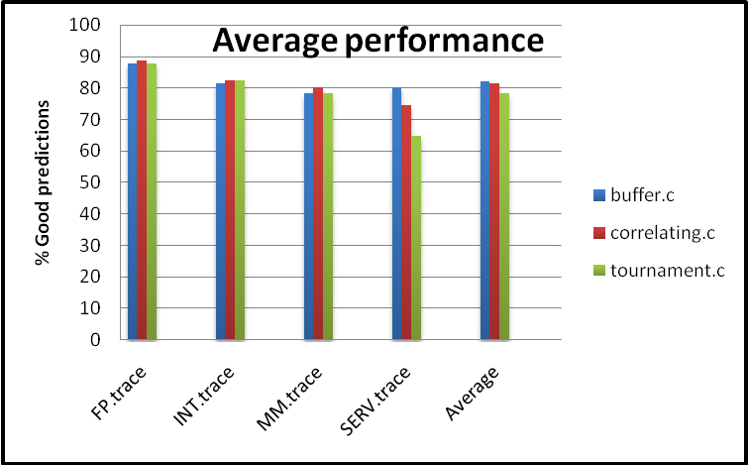
Figure 3.3: Comparing the average performance of branch prediction algorithms

Figure 3.3 shows that the performance of each prediction scheme differs from trace to trace. Specifically, the buffer predictor is significantly more accurate than the other two in the SERV trace.
The correlating predictor has the same performance with the buffer predictor in FP and MM traces, but is slightly better in the INT trace. However, its performance highly drops in the SERV trace.
The tournament predictor is slightly better in FP and MM traces, but it cannot compete with the buffer predictor in the SERV trace.
Finally, if we consider the average performance for all traces, the results show that the buffer is slightly ahead of the other two prediction schemes.

Appendix I: Code included

I-A) Overview

All the results were generated using C code on a 32 bit Linux platform. The scripts were compiled using gcc and debugged using ddd.
Notes:
- All code files are located in the subdirectory ‘code/’
- The code will probably not compile and will definitely not work properly on a Windows platform
Code files included:
static.c: Gives out statistics on the number of branches taken/not taken without any prediction algorithm.
buffer.c: Implements a buffer prediction algorithm. Every trace will be tested for 2,4,…,20 byte buffers
correlating.c: Implements a correlating prediction algorithm, which uses an 8-bit global predictor to select from 256 local predictors/branch address. Every trace will be tested for 2,4,…,20 byte buffers
tournament.c: Every branch is passed through a buffer as well as a correlating predictor. Based on previous accuracies of both predictors, a 2-bit controller selects which predictor to implement.

I-B) How to compile and run

Instructions:
- To get gcc, open a terminal window in Linux and type $ sudo apt-get install gcc
- In order for the trace files to be accessed, they need to be placed in a directory called ‘traces/’, to which the directory containing the program is root (e.g. code/traces/).
- To compile a code file, type $ gcc filename.c –w
- To execute the binary produced, type $ ./a.out

Appendix II: Data collected

II-A) static.c

FP.trace
Total BR: 2213673 Taken: 412899 Ratio: 18%
INT.trace
Total BR: 4184792 Taken: 1068045 Ratio: 25%
MM.trace
Total BR: 2229289 Taken: 713587 Ratio: 32%
SERV.trace
Total BR: 3660616 Taken: 1111595 Ratio: 30%

II-B) Prediction schemes

 |  |  | buffer.c |  | correlating.c |  | tournament.c
 | bits | TotBR | GoodPr | % good | GoodPr | % good | GoodPr | % good
FP.trace | 2 | 2213673 | 2041014 | 92 | 2070849 | 93 | 2040070 | 92
 | 4 | 2213673 | 2045204 | 92 | 2070828 | 93 | 2044077 | 92
 | 6 | 2213673 | 2037944 | 92 | 2061395 | 93 | 2036417 | 91
 | 8 | 2213673 | 2034160 | 91 | 2056295 | 92 | 2030878 | 91
 | 10 | 2213673 | 2024693 | 91 | 2044533 | 92 | 2021957 | 91
 | 12 | 2213673 | 1990585 | 89 | 2006191 | 90 | 1990710 | 89
 | 14 | 2213673 | 1918330 | 86 | 1933428 | 87 | 1918330 | 86
 | 16 | 2213673 | 1869871 | 84 | 1881298 | 84 | 1869870 | 84
 | 18 | 2213673 | 1800774 | 81 | 1800774 | 81 | 1800774 | 81
 | 20 | 2213673 | 1800774 | 81 | 1800774 | 81 | 1800774 | 81

 |  |  | buffer.c |  | correlating.c |  | tournament.c
 | bits | TotBR | GoodPr | % good | GoodPr | % good | GoodPr | % good
INT.trace | 2 | 4184792 | 3761918 | 89 | 3766125 | 89 | 3749958 | 89
 | 4 | 4184792 | 3658473 | 87 | 3716688 | 88 | 3702496 | 88
 | 6 | 4184792 | 3564452 | 85 | 3646954 | 87 | 3643838 | 87
 | 8 | 4184792 | 3573771 | 85 | 3656075 | 87 | 3655361 | 87
 | 10 | 4184792 | 3557480 | 85 | 3632158 | 86 | 3607969 | 86
 | 12 | 4184792 | 3507075 | 83 | 3562238 | 85 | 3532909 | 84
 | 14 | 4184792 | 3372952 | 80 | 3395253 | 81 | 3376535 | 80
 | 16 | 4184792 | 3126537 | 74 | 3126532 | 74 | 3126536 | 74
 | 18 | 4184792 | 3116747 | 74 | 3116747 | 74 | 3116747 | 74
 | 20 | 4184792 | 3116747 | 74 | 3116747 | 74 | 3116747 | 74

MM.trace | 2 | 2229289 | 1905842 | 85 | 1918628 | 86 | 1895885 | 85
 | 4 | 2229289 | 1908492 | 85 | 1920977 | 86 | 1912730 | 85
 | 6 | 2229289 | 1905796 | 85 | 1922498 | 86 | 1910134 | 85
 | 8 | 2229289 | 1898798 | 85 | 1923038 | 86 | 1901594 | 85
 | 10 | 2229289 | 1876778 | 84 | 1902297 | 85 | 1877087 | 84
 | 12 | 2229289 | 1812288 | 81 | 1868053 | 83 | 1813427 | 81
 | 14 | 2229289 | 1703586 | 76 | 1799523 | 80 | 1703504 | 76
 | 16 | 2229289 | 1537199 | 68 | 1699376 | 76 | 1537199 | 68
 | 18 | 2229289 | 1515702 | 67 | 1515702 | 67 | 1515702 | 67
 | 20 | 2229289 | 1515702 | 67 | 1515702 | 67 | 1515702 | 67

SERV.trace | 2 | 3660616 | 3325242 | 90 | 3134406 | 85 | 2667523 | 72
 | 4 | 3660616 | 3297983 | 90 | 2940661 | 80 | 2651695 | 72
 | 6 | 3660616 | 3261423 | 89 | 2846581 | 77 | 2616696 | 71
 | 8 | 3660616 | 3149829 | 86 | 2775663 | 75 | 2520838 | 68
 | 10 | 3660616 | 3006560 | 82 | 2728744 | 74 | 2382900 | 65
 | 12 | 3660616 | 2895137 | 79 | 2709956 | 74 | 2263377 | 61
 | 14 | 3660616 | 2751657 | 75 | 2667985 | 72 | 2113811 | 57
 | 16 | 3660616 | 2655985 | 72 | 2613431 | 71 | 2311200 | 63
 | 18 | 3660616 | 2557681 | 69 | 2549021 | 69 | 2213557 | 60
 | 20 | 3660616 | 2549021 | 69 | 2549021 | 69 | 2210291 | 60

 |  |  | buffer.c |  | correlating.c |  | tournament.c
 |  | TotBR | GoodPr | % good | GoodPr | % good | GoodPr | % good
FP.trace |  | 2213673 | 1956335 | 87.9 | 1972637 | 88.6 | 1955386 | 87.8
INT.trace |  | 4184792 | 3435615 | 81.6 | 3473552 | 82.5 | 3462910 | 82.3
MM.trace |  | 2229289 | 1758018 | 78.3 | 1798579 | 80.2 | 1758296 | 78.3
SERV.trace |  | 3660616 | 2945052 | 80.1 | 2751547 | 74.6 | 2395189 | 64.9
Average |  | 3072093 | 2523755 | 81.975 | 2499079 | 81.475 | 2392945 | 78.325

Appendix III: Source C code

III-A) Static.c

/************************************/
/* Comp Arc Project
/* By: Simon Foucher
/* 260 223 197
/************************************/

/************************************/
/* includes and definitions
/************************************/
#include <stdio.h>
#include <stdlib.h>
#include <string.h>
#include <ctype.h>

#define TRUE 1
#define FALSE 0
typedef int BOOL;

/************************************/
/* Function declarations
/************************************/

/************************************/
/* Global Variables & datatypes
/************************************/

/************************************/
/* Functions
/************************************/

// To clean up gathered strings from text
void stripCRLF(char array[])
{
int i;

for(i=0;i<500 && array[i]!='\0';i++)
if (array[i]=='\r' || array[i]=='\n')
array[i]='\0';
}

void readTrace(FILE *fp)
{
// Following arrays used to store statistical data (related elements share a common index)
char addresses[10000][20];
int frequency[10000];
int taken[10000];
int totalBR = 0, totalTak = 0;

char temp[50];
char tmpAddress[10];
int i, j, k;

// Format arrays
for(i = 0; i < 10000; i++){
frequency[i] = 0;
taken[i] = 0;
}

// Extract lines of data; break at EOF
while( fgets(temp, sizeof(temp), fp) != NULL ){

stripCRLF(temp); // Clean up the string
//fputs(temp, stdout);
totalBR++;

for(i = 0; ; i++){ // Extract address of branch
tmpAddress[i] = temp[i];
if(tmpAddress[i] == ' ')
break;
}

tmpAddress[i++] = NULL; // Add a proper null terminator and increment index (i points at branch result)

//for(;i<15; i++)
// printf("--temp[%d] = %d\n",i, temp[i]);

for(k = 0; k < 10000; k++) // Find out if the entry already exists
if(addresses[k][0] == NULL || !strncmp(addresses[k], tmpAddress, 9))
break;

if(k != 9999){ // If it is a new entry, k points at the first empt spot
if(addresses[k][0] == NULL)
//printf("\tNew Entry: %s \tat index: %d \t taken (if 1) '%c' \n\t", tmpAddress, k, temp[i]);
strcpy(addresses[k], tmpAddress);
}

// At this point, i points at the branch result and k at the array index whete the element goes.
// record the statistics
frequency[k]++;

// ASCII 48 = 0, 49 = 1
if(temp[i] == 49){
taken[k] += 1;
totalTak += 1;
}

//printf("\tAddress: %s, \t used: %d, \t Taken: %d\n", addresses[k], frequency[k], taken[k]);

}// End of while getting lines

fclose(fp);

printf("\n DONE!!\n\nResults:\n");

/* for(k = 0; k < 9999; k++){
if(addresses[k][0] == NULL)
break;
printf("k: %d\t Add: %s\tTaken: %d\tFreq: %d\tRatio: %d\n", k, addresses[k], taken[k], frequency[k], taken[k]*100/frequency[k]);
}
*/
printf("\n\nTotal BR: %d\tTaken: %d\tRatio: %d%\n\n",totalBR, totalTak, totalTak*100/totalBR);
printf("---------------------------------------------\n");

}// End if readTrace

/*******************************************************************************/
/* Function main (int argc, char *argv[])
/*******************************************************************************/

int main (int argc, char *argv[])
{
FILE *fp;

// FP.trace
if((fp = fopen("traces/FP.trace","r"))==NULL) //Open the password file
{
puts("Cannot open FP.trace\n"
"Please make sure it is located in a directory called 'traces/'\n"
"having this program's directory as a root\n");
}
else
printf("Sucessfully opened FP.trace\nStarting analysis\n");

readTrace(fp);

// INT.trace
if((fp = fopen("traces/INT.trace","r"))==NULL) //Open the password file
{
puts("Cannot open INT.trace\n"
"Please make sure it is located in a directory called 'traces/'\n"
"having this program's directory as a root\n");
}
else
printf("Sucessfully opened INT.trace\nStarting analysis\n\n");

readTrace(fp);

// MM.trace
if((fp = fopen("traces/MM.trace","r"))==NULL) //Open the password file
{
puts("Cannot open MM.trace\n"
"Please make sure it is located in a directory called 'traces/'\n"
"having this program's directory as a root\n");
}
else
printf("Sucessfully opened MM.trace\nStarting analysis\n\n");

readTrace(fp);

// SERV.trace
if((fp = fopen("traces/SERV.trace","r"))==NULL) //Open the password file
{
puts("Cannot open SERV.trace\n"
"Please make sure it is located in a directory called 'traces/'\n"
"having this program's directory as a root\n");
}
else
printf("Sucessfully opened SERV.trace\nStarting analysis\n\n");

readTrace(fp);

}

III-B) Buffer.c

/************************************/
/* Comp Arc Project
/* By: Simon Foucher
/* 260 223 197
/************************************/

/************************************/
/* includes and definitions
/************************************/
#include <stdio.h>
#include <stdlib.h>
#include <string.h>
#include <ctype.h>

/************************************/
/* Function declarations
/************************************/

/************************************/
/* Global Variables & datatypes
/************************************/
#define TRUE 1
#define FALSE 0
typedef int BOOL;

/************************************/
/* Functions
/************************************/

// To clean up gathered strings from text
void stripCRLF(char array[])
{
int i;

for(i=0;i<500 && array[i]!='\0';i++)
if (array[i]=='\r' || array[i]=='\n')
array[i]='\0';
}

// To compute power
int power(int x, int n){

if(n == 0)
return 1;

else{
int tmp = power(x, n/2);
if(n%2)
return tmp*tmp*x;
else
return tmp*tmp;
}

}

void readTrace(FILE *fp, int Nbits)
{

// Following arrays used to store statistical data (related elements share a common index)
char addresses[100000][20];
int predictorLocal[100000];
int totalBR = 0, totalGoodPredictions = 0;
int Nmask, treshold;

char temp[50];
char tmpAddress[10];
int i, j, k;
int done;

/************************************ INITIALIZATION ************************************************/

// Format arrays with preditction not taken
for(i = 0; i < 100000; i++){
predictorLocal[i] = 0;
}

// Build bit mask for N bit predictor
Nmask = power(2, Nbits);
treshold = Nmask/2;

// DEBUGGING
// printf("N = %d\t2^N = %d\tMask: 0x%x\n", Nbits, Nmask+1,Nmask);

/************************************ DATA FETCH ************************************************/
// Extract lines of data; break at EOF
while( fgets(temp, sizeof(temp), fp) != NULL ){

stripCRLF(temp); // Clean up the string
//printf("Line: %s", temp);
totalBR++; // Increment total branch count

for(i = 0; ; i++){ // Extract address of branch
tmpAddress[i] = temp[i];
if(tmpAddress[i] == ' ')
break;
}

tmpAddress[i++] = NULL; // Add a proper null terminator and increment index (i points at branch result)

//for(;i<15; i++)
// printf("--temp[%d] = %d\n",i, temp[i]);

for(k = 0; k < 100000; k++) // Find out if the entry already exists
if(addresses[k][0] == NULL || !strncmp(addresses[k], tmpAddress, 9))
break;

if(k != 99999){ // If it is a new entry, k points at the first empt spot
if(addresses[k][0] == NULL)
strcpy(addresses[k], tmpAddress);
}
else
printf("Warning! Reached end of buffer!!!!\n");

/************************************ PREDICTOR ************************************************/
/* At this point, i points at the branch result and k at the array index whete the element goes
NOTES:
* ASCII 48 = 0, 49 = 1
* Example with 8 bits used for comments
* The 4 cases evaluated are mutually exclusive (unlike in correlating predictor)
*/
//printf("pred Was: %x\t", predictorLocal[k]);

// If predict "NOT taken
// So predict Local is < 0001 0000 equivalent to Renge of [0000 0000, 0000 1111]
if(predictorLocal[k] < treshold){
// If branch IS taken
if(temp[i] == 49){
totalGoodPredictions += 0; // Bad prediction

predictorLocal[k] +=1; // Increment the predictor
if(predictorLocal[k] == treshold) // If we hit the turning point (0001 0000), jump to "strong taken"(1111 1111)
predictorLocal[k] = Nmask - 1; // Nmask = 1 0000 0000 so Nmask - 1 = 1111 1111 = strong taken
}
// If branch NOT taken
if(temp[i] == 48){
totalGoodPredictions += 1; // Good prediction
if(predictorLocal[k] != 0) // If predictor != 0000 0000
predictorLocal[k] -= 1; // Reflect last BR decision ourcome (LSB of 0)
}
}

// If predict "IS taken"
// If predictorLocal is in the range [0001 0000, 1111 1111]
if(predictorLocal[k] >= treshold){
// If branch IS taken
if(temp[i] == 49){
totalGoodPredictions += 1; // Good prediction

if(predictorLocal[k] != Nmask - 1) // If predictor < 1 0000 0000 = Range og [0001 0000, 1111 1111]
predictorLocal[k] += 1; // increment by 1
}
// If branch NOT taken
if(temp[i] == 48){
totalGoodPredictions += 0; // Bad prediction
predictorLocal[k] -= 1; // Reflect last BR decision ourcome (LSB of 0)

if(predictorLocal[k] == treshold - 1) // If we got to 0000 1111
predictorLocal[k] = 0; // Jump to predict strong not taken 0000 0000
}
}

//printf("pred New: %x\t", predictorLocal[k]);
if(predictorLocal[k] == Nmask) // Avoid overflow (I don't think this is possible, but just in case...)
predictorLocal[k]--;
//printf("pred Masked: %x\n", predictorLocal[k]);

}// End of while getting lines

/*/ Counts the number of different addresses
for(k=0;;k++)
if(addresses[k][0] == NULL)
break;
printf("K=%d\n",k);
*/

printf("%d\t%d\t%d\t\t%d\n", Nbits, totalGoodPredictions, totalBR, totalGoodPredictions*100/totalBR);

}// End if readTrace

/*******************************************************************************/
/* Function main (int argc, char *argv[])
/*******************************************************************************/

int main (int argc, char *argv[])
{
FILE *fp;
int Nbits;

//FP had 430 different branch address
printf("---------------------------------------------\n");
// Open FP.trace
if((fp = fopen("traces/FP.trace","r"))==NULL) //Open the password file
{
puts("Cannot open FP.trace\n"
"Please make sure it is located in a directory called 'traces/'\n"
"having this program's directory as a root\n");
}
else
printf("FP.trace Analysis\n");

printf("Nbits\tGoodPr\tTotBR\t\tAccuracy(%)\n");
for(Nbits = 2; Nbits <=20; Nbits +=2){
rewind(fp); // Rewind file pointer
readTrace(fp, Nbits);
}

fclose(fp);
printf("\n---------------------------------------------\n");

// Open INT.trace
if((fp = fopen("traces/INT.trace","r"))==NULL) //Open the password file
{
puts("Cannot open INT.trace\n"
"Please make sure it is located in a directory called 'traces/'\n"
"having this program's directory as a root\n");
}
else
printf("INT.trace Analysis\n");

printf("Nbits\tGoodPr\tTotBR\t\tAccuracy(%)\n");
for(Nbits = 2; Nbits <=20; Nbits +=2){
rewind(fp); // Rewind file pointer
readTrace(fp, Nbits);
}

fclose(fp);
printf("\n---------------------------------------------\n");

// Open MM.trace
if((fp = fopen("traces/MM.trace","r"))==NULL) //Open the password file
{
puts("Cannot open MM.trace\n"
"Please make sure it is located in a directory called 'traces/'\n"
"having this program's directory as a root\n");
}
else
printf("MM.trace Analysis\n");

printf("Nbits\tGoodPr\tTotBR\t\tAccuracy(%)\n");
for(Nbits = 2; Nbits <=20; Nbits +=2){
rewind(fp); // Rewind file pointer
readTrace(fp, Nbits);
}

fclose(fp);
printf("\n---------------------------------------------\n");

//Server has 10 388 Different branch address

// Open SERV.trace
if((fp = fopen("traces/SERV.trace","r"))==NULL) //Open the password file
{
puts("Cannot open SERV.trace\n"
"Please make sure it is located in a directory called 'traces/'\n"
"having this program's directory as a root\n");
}
else
printf("SERV.trace Analysis\n");

printf("Nbits\tGoodPr\tTotBR\t\tAccuracy(%)\n");
for(Nbits = 2; Nbits <=20; Nbits +=2){
rewind(fp); // Rewind file pointer
readTrace(fp, Nbits);
}

fclose(fp);
printf("\n---------------------------------------------\n");

}

III-C) Correlating.c
/************************************/
/* Comp Arc Project
/* By: Simon Foucher
/* 260 223 197
/************************************/

/************************************/
/* includes and definitions
/************************************/
#include <stdio.h>
#include <stdlib.h>
#include <string.h>
#include <ctype.h>

/************************************/
/* Function declarations
/************************************/

/************************************/
/* Global Variables & datatypes
/************************************/
#define TRUE 1
#define FALSE 0
typedef int BOOL;

/************************************/
/* Functions
/************************************/

// To clean up gathered strings from text
void stripCRLF(char array[])
{
int i;

for(i=0;i<500 && array[i]!='\0';i++)
if (array[i]=='\r' || array[i]=='\n')
array[i]='\0';
}

// To compute power
int power(int x, int n){

if(n == 0)
return 1;

else{
int tmp = power(x, n/2);
if(n%2)
return tmp*tmp*x;
else
return tmp*tmp;
}

}

void readTrace(FILE *fp, int Nbits, int tooBig)
{

char addresses[1000][20];
// 8 bits global predictor can represent 0d numbers ranging from [0,255]
int predictorGlobal;

// 8 198 x 255 is the largest array that can be declared in a 32 bits Linux machine without getting a segmentation fault.
int predictorLocal[8100][256]; // Tha largest file is SERV which has 10 388 different addresses
int totalBR = 0, totalGoodPredictions = 0;
int Nmask, treshold;
char temp[50];
char tmpAddress[11];
int i, j, k;

//************************************ INITIALIZATION ************************************************

// Format arrays with preditction not taken
predictorGlobal = 0;
for(i = 0; i < 8100; i++){
for(k = 0; k < 256; k++)
predictorLocal[i][k] = 0;
}

// Build bit mask for N bit predictor
Nmask = power(2, Nbits);
treshold = (Nmask)/2;

// DEBUGGING
// printf("N = %d\t2^N = %d\tMask: 0x%x\n", Nbits, Nmask+1,Nmask);

//************************************ DATA FETCH ************************************************
// Extract lines of data; break at EOF
while( fgets(temp, sizeof(temp), fp) != NULL ){

stripCRLF(temp); // Clean up the string
//printf("Line: %s", temp);
totalBR++; // Increment total branch count

if(tooBig) // If the address space is too big, skip the first digit
k = 1;
else
k = 0; // Otherwise copy the while string

for(i = 0; ; i++, k++){ // Extract address of branch
tmpAddress[i] = temp[k];
if(tmpAddress[i] == ' ')
break;
}

tmpAddress[i++] = NULL; // Add a proper null terminator and increment index (i points at branch result)

if(tooBig)
i++;

for(k = 0; k < 1000; k++) // Find out if the entry already exists
if(addresses[k][0] == NULL || !strncmp(addresses[k], tmpAddress, 10))
break;

if(k != 8099){ // If it is a new entry, k points at the first empt spot
if(addresses[k][0] == NULL)
strcpy(addresses[k], tmpAddress);
}
else // Warning if we busr out of memory
printf("Warning! Reached end of buffer!!!!\n");

//************************************ PREDICTOR ************************************************
// At this point, i points at the branch result and k at the array index whete the element goes
// NOTES:
// ASCII 48 = 0, 49 = 1

//printf("pred Was: %x\t", predictorLocal[k]);

// If predict "NOT taken
// So predict Local is < 0001 0000 equivalent to Renge of [0000 0000, 0000 1111]
if(predictorLocal[k][predictorGlobal] < treshold){
// If branch IS taken
if(temp[i] == 49){
// Update # of good predictions
totalGoodPredictions += 0; // Bad prediction

// Update Local predictor & jump if reach treshold
predictorLocal[k][predictorGlobal] +=1; // Increment the predictor
if(predictorLocal[k][predictorGlobal] == treshold) // Hit turning point (0001 0000), jump to "strong taken"(1111 1111)
predictorLocal[k][predictorGlobal] = Nmask - 1; // Nmask = 1 0000 0000 so Nmask - 1 = 1111 1111 = strong taken

// Update Global predictor if not at its max value
if(predictorGlobal != 255)
predictorGlobal++;
}

// If branch NOT taken
if(temp[i] == 48){
// Update # of good predictions
totalGoodPredictions += 1; // Good prediction

// Update Local predictor if we are not at edge value
if(predictorLocal[k][predictorGlobal] != 0) // If predictor != 0000 0000
predictorLocal[k][predictorGlobal] -= 1; // Reflect last BR decision ourcome (LSB of 0)
}

// Update Global predictor if not at its max value
if(predictorGlobal != 255)
predictorGlobal++;

}

// If predict "IS taken"
// If predictorLocal is in the range [0001 0000, 1111 1111]
if(predictorLocal[k][predictorGlobal] >= treshold){
// If branch IS taken
if(temp[i] == 49){
// Update # of good predictions
totalGoodPredictions += 1; // Good prediction

// Update Local predictor if we are not at edge value
if(predictorLocal[k][predictorGlobal] != Nmask - 1) // If predictor < 1 0000 0000 = Range og [0001 0000, 1111 1111]
predictorLocal[k][predictorGlobal] += 1; // increment by 1

// Update Global predictor if not at its min value
if(predictorGlobal != 0)
predictorGlobal--;
}

// If branch NOT taken
if(temp[i] == 48){
// Update # of good predictions
totalGoodPredictions += 0; // Bad prediction
predictorLocal[k][predictorGlobal] -= 1; // Reflect last BR decision ourcome (LSB of 0)

// Update Local predictor & jump if reach treshold
if(predictorLocal[k][predictorGlobal] == treshold - 1) // If we got to 0000 1111
predictorLocal[k][predictorGlobal] = 0; // Jump to predict strong not taken 0000 0000

// Update Global predictor if not at its min value
if(predictorGlobal != 0)
predictorGlobal--;
}
}

//printf("pred New: %x\t", predictorLocal[k]);
if(predictorLocal[k][predictorGlobal] == Nmask) // Avoid overflow
predictorLocal[k][predictorGlobal]--;
if(predictorGlobal == 256)
predictorGlobal--;
//printf("pred Masked: %x\n", predictorLocal[k]);

}// End of while getting lines

printf("%d\t%d\t%d\t\t%d\n", Nbits, totalGoodPredictions, totalBR, totalGoodPredictions*100/totalBR);

}// End if readTrace

/*******************************************************************************/
/* Function main (int argc, char *argv[])
/*******************************************************************************/

int main (int argc, char *argv[])
{
FILE *fp;
int Nbits;

printf("---------------------------------------------\n");
// Open FP.trace
if((fp = fopen("traces/FP.trace","r"))==NULL) //Open the password file
{
puts("Cannot open FP.trace\n"
"Please make sure it is located in a directory called 'traces/'\n"
"having this program's directory as a root\n");
}
else
printf("FP.trace Analysis\n");

printf("Nbits\tGoodPr\tTotBR\t\tAccuracy(%)\n");
for(Nbits = 2; Nbits <=20; Nbits +=2){
rewind(fp); // Rewind file pointer
readTrace(fp, Nbits, 0);
}

fclose(fp);
printf("\n---------------------------------------------\n");

// Open INT.trace
if((fp = fopen("traces/INT.trace","r"))==NULL) //Open the password file
{
puts("Cannot open INT.trace\n"
"Please make sure it is located in a directory called 'traces/'\n"
"having this program's directory as a root\n");
}
else
printf("INT.trace Analysis\n");

printf("Nbits\tGoodPr\tTotBR\t\tAccuracy(%)\n");
for(Nbits = 2; Nbits <=20; Nbits +=2){
rewind(fp); // Rewind file pointer
readTrace(fp, Nbits, 0);
}

fclose(fp);
printf("\n---------------------------------------------\n");

// Open MM.trace
if((fp = fopen("traces/MM.trace","r"))==NULL) //Open the password file
{
puts("Cannot open MM.trace\n"
"Please make sure it is located in a directory called 'traces/'\n"
"having this program's directory as a root\n");
}
else
printf("MM.trace Analysis\n");

printf("Nbits\tGoodPr\tTotBR\t\tAccuracy(%)\n");
for(Nbits = 2; Nbits <=20; Nbits += 2){
rewind(fp); // Rewind file pointer
readTrace(fp, Nbits, 0);
}

fclose(fp);
printf("\n---------------------------------------------\n");

// Open SERV.trace
if((fp = fopen("traces/SERV.trace","r"))==NULL) //Open the password file
{
puts("Cannot open SERV.trace\n"
"Please make sure it is located in a directory called 'traces/'\n"
"having this program's directory as a root\n");
}
else
printf("SERV.trace Analysis\n");

printf("Nbits\tGoodPr\tTotBR\t\tAccuracy(%)\n");
for(Nbits = 2; Nbits <=20; Nbits +=2){
rewind(fp); // Rewind file pointer
readTrace(fp, Nbits, 1);
}

fclose(fp);
printf("\n---------------------------------------------\n");

}
III-D) Tournament.c
/************************************/
/* Comp Arc Project
/* By: Simon Foucher
/* 260 223 197
/************************************/

/************************************/
/* includes and definitions
/************************************/
#include <stdio.h>
#include <stdlib.h>
#include <string.h>
#include <ctype.h>

/************************************/
/* Function declarations
/************************************/

/************************************/
/* Global Variables & datatypes
/************************************/
#define TRUE 1
#define FALSE 0
typedef int BOOL;

/************************************/
/* Functions
/************************************/

// To clean up gathered strings from text
void stripCRLF(char array[])
{
int i;

for(i=0;i<500 && array[i]!='\0';i++)
if (array[i]=='\r' || array[i]=='\n')
array[i]='\0';
}

// To compute power
int power(int x, int n){

if(n == 0)
return 1;

else{
int tmp = power(x, n/2);
if(n%2)
return tmp*tmp*x;
else
return tmp*tmp;
}

}

void readTrace(FILE *fp, int Nbits)
{
// Data gathering variables & common
char addresses[8000][20];
char temp[50];
char tmpAddress[10];
int i, j, k;

// Buffer (n bit) Predictor data
int BufferPredictor[8000];
int NmaskBuffer, tresholdBuffer;
int bufferPrediction;

// Correlating Predictor data
int predictorGlobal;
int correlatingPredictor[1000][255];
int NmaskCorrelator, tresholdCorrelator;
int correlatorPrediction;

// Chooser table
int chooser[8000];

// Statistical variables
int totalBR = 0, totalGoodPredictions = 0;

/************************************ INITIALIZATION ************************************************/

// Format arrays with preditction not taken
predictorGlobal = 0;
for(i = 0; i < 8000; i++){
BufferPredictor[i] = 0; // Buffer predictor
chooser[i] = 0; // Chooser
for(k = 0; k < 256; k++)
correlatingPredictor[i][k] = 0; // Correlating predictor
}

// Build bit mask for predictors
NmaskBuffer = power(2, Nbits);
tresholdBuffer = NmaskBuffer/2;

NmaskCorrelator = power(2, Nbits);
tresholdCorrelator = (NmaskCorrelator)/2;

/************************************ DATA FETCH ************************************************/
// Extract lines of data; break at EOF
while( fgets(temp, sizeof(temp), fp) != NULL ){

stripCRLF(temp); // Clean up the string
//printf("Line: %s", temp);
totalBR++; // Increment total branch count

for(i = 0; ; i++){ // Extract address of branch
tmpAddress[i] = temp[i];
if(tmpAddress[i] == ' ')
break;
}

tmpAddress[i++] = NULL; // Add a proper null terminator and increment index (i points at branch result)

//for(;i<15; i++)
// printf("--temp[%d] = %d\n",i, temp[i]);

for(k = 0; k < 8000; k++) // Find out if the entry already exists
if(addresses[k][0] == NULL || !strncmp(addresses[k], tmpAddress, 9))
break;

if(k != 7999){ // If it is a new entry, k points at the first empt spot
if(addresses[k][0] == NULL)
strcpy(addresses[k], tmpAddress);
}
else
printf("Warning! Reached end of buffer!!!!\n");

/************************************ BUFFER PREDICTOR ************************************************/

// If predict "NOT taken
// So predict Local is < 0001 0000 equivalent to Renge of [0000 0000, 0000 1111]
if(BufferPredictor[k] < tresholdBuffer){
bufferPrediction = 0; // Save result of the prediction
// If branch IS taken
if(temp[i] == 49){
BufferPredictor[k] +=1; // Increment the predictor
if(BufferPredictor[k] == tresholdBuffer) // Hit the turning point (0001 0000), jump to "strong taken"(1111 1111)
BufferPredictor[k] = NmaskBuffer - 1; // NmaskBuffer = 1 0000 0000 so NmaskBuffer - 1 = 1111 1111 = strong taken
}
// If branch NOT taken
if(temp[i] == 48){
if(BufferPredictor[k] != 0) // If predictor != 0000 0000
BufferPredictor[k] -= 1; // Reflect last BR decision ourcome (LSB of 0)
}
}

// If predict "IS taken"
// If BufferPredictor is in the range [0001 0000, 1111 1111]
if(BufferPredictor[k] >= tresholdBuffer){
bufferPrediction = 1; // Save result of the prediction

// If branch IS taken
if(temp[i] == 49){
if(BufferPredictor[k] != NmaskBuffer - 1) // If predictor < 1 0000 0000 = Range og [0001 0000, 1111 1111]
BufferPredictor[k] += 1; // increment by 1
}
// If branch NOT taken
if(temp[i] == 48){
BufferPredictor[k] -= 1; // Reflect last BR decision ourcome (LSB of 0)

if(BufferPredictor[k] == tresholdBuffer - 1) // If we got to 0000 1111
BufferPredictor[k] = 0; // Jump to predict strong not taken 0000 0000
}
}

if(BufferPredictor[k] == NmaskBuffer) // Avoid overflow (I don't think this is possible, but just in case...)
BufferPredictor[k]--;

//************************************ CORRELATING PREDICTOR ************************************************

// If predict "NOT taken
// So predict Local is < 0001 0000 equivalent to Renge of [0000 0000, 0000 1111]
if(correlatingPredictor[k][predictorGlobal] < tresholdCorrelator){
correlatorPrediction = 0; // Save result
// If branch IS taken
if(temp[i] == 49){
// Update Local predictor & jump if reach tresholdCorrelator
correlatingPredictor[k][predictorGlobal] +=1; // Increment the predictor
if(correlatingPredictor[k][predictorGlobal] == tresholdCorrelator) // Hit turning point (0001 0000), jump to "strong taken"(1111 1111)
correlatingPredictor[k][predictorGlobal] = NmaskCorrelator - 1; // NmaskCorrelator = 1 0000 0000 so NmaskCorrelator - 1 = 1111 1111 = strong taken

// Update Global predictor if not at its max value
if(predictorGlobal != 255)
predictorGlobal++;
}

// If branch NOT taken
if(temp[i] == 48){
// Update Local predictor if we are not at edge value
if(correlatingPredictor[k][predictorGlobal] != 0) // If predictor != 0000 0000
correlatingPredictor[k][predictorGlobal] -= 1; // Reflect last BR decision ourcome (LSB of 0)
}

// Update Global predictor if not at its max value
if(predictorGlobal != 255)
predictorGlobal++;
}

// If predict "IS taken"
// If correlatingPredictor is in the range [0001 0000, 1111 1111]
if(correlatingPredictor[k][predictorGlobal] >= tresholdCorrelator){
correlatorPrediction = 1; // Save result
// If branch IS taken
if(temp[i] == 49){
// Update Local predictor if we are not at edge value
if(correlatingPredictor[k][predictorGlobal] != NmaskCorrelator - 1) // If predictor < 1 0000 0000 = Range og [0001 0000, 1111 1111]
correlatingPredictor[k][predictorGlobal] += 1; // increment by 1

// Update Global predictor if not at its min value
if(predictorGlobal != 0)
predictorGlobal--;
}

// If branch NOT taken
if(temp[i] == 48){
correlatingPredictor[k][predictorGlobal] -= 1; // Reflect last BR decision ourcome (LSB of 0)

// Update Local predictor & jump if reach tresholdCorrelator
if(correlatingPredictor[k][predictorGlobal] == tresholdCorrelator - 1) // If we got to 0000 1111
correlatingPredictor[k][predictorGlobal] = 0; // Jump to predict strong not taken 0000 0000

// Update Global predictor if not at its min value
if(predictorGlobal != 0)
predictorGlobal--;
}
}

if(correlatingPredictor[k][predictorGlobal] == NmaskCorrelator) // Avoid overflow
correlatingPredictor[k][predictorGlobal]--;
if(predictorGlobal == 256)
predictorGlobal--;

//************************************** CHOOSER *****************************************************
// Here, 'bufferPrediction' and 'correlatorPrediction' contain the predict results of both algorithms
// The branch result is evaluating a second time (redundent, but we are not aiming for performance)
// The chooser are 2 bit numbers, ranginf from 00 = 0 to 11 = 3. Their treshold is 2.
// Chooser 0,1 prefers Buffer
// Chooser 2,3 prefers Correlator

switch(chooser[k]) {
// case 0, 1 select Buffer predictor
case 0:
if(temp[i] == 49){ // If branch IS taken
if(bufferPrediction == 1) // Predict IS taken
totalGoodPredictions++; // Good prediction = update good prediction counter
if(bufferPrediction == 0) // Predict NOT taken
chooser[k] = 1; // Bad prediction = Update chooser
}
if(temp[i] == 48){ // If branch NOT taken
if(bufferPrediction == 1) // Predict IS taken
chooser[k] = 1; // Bad prediction = Update chooser
if(bufferPrediction == 0) // Predict NOT taken
totalGoodPredictions++; // Good prediction = update good prediction counter
}
break;

case 1:
if(temp[i] == 49){ // If branch IS taken
if(bufferPrediction == 1){ // Predict IS taken
totalGoodPredictions++; // Good prediction = update good prediction counter
chooser[k] = 0; // Good prediction = update chooser to stable
}
if(bufferPrediction == 0) // Predict NOT taken
chooser[k] = 3; // Bad prediction = Update chooser
}
if(temp[i] == 48){ // If branch NOT taken
if(bufferPrediction == 1) // Predict IS taken
chooser[k] = 3; // Bad prediction = Update chooser
if(bufferPrediction == 0){ // Predict NOT taken
totalGoodPredictions++; // Good prediction = update good prediction counter
chooser[k] = 0; // Good prediction = update chooser to stable
}
}
break;

// case 2,3 select correlating predictor
case 2:
if(temp[i] == 49){ // If branch IS taken
if(correlatorPrediction == 1){ // Predict IS taken
totalGoodPredictions++; // Good prediction = update good prediction counter
chooser[k] = 3; // Good prediction = update chooser to stable
}
if(correlatorPrediction == 0) // Predict NOT taken
chooser[k] = 0; // Bad prediction = Update chooser
}
if(temp[i] == 48){ // If branch NOT taken
if(correlatorPrediction == 1) // Predict IS taken
chooser[k] = 0; // Bad prediction = Update chooser
if(correlatorPrediction == 0){ // Predict NOT taken
totalGoodPredictions++; // Good prediction = update good prediction counter
chooser[k] = 3; // Good prediction = update chooser to stable
}
}
break;

case 3:
if(temp[i] == 49){ // If branch IS taken
if(correlatorPrediction == 1){ // Predict IS taken
totalGoodPredictions++; // Good prediction = update good prediction counter
chooser[k] = 3; // Good prediction = update chooser to stable
}
if(correlatorPrediction == 0) // Predict NOT taken
chooser[k] = 2; // Bad prediction = Update chooser
}
if(temp[i] == 48){ // If branch NOT taken
if(correlatorPrediction == 1) // Predict IS taken
chooser[k] = 2; // Bad prediction = Update chooser
if(correlatorPrediction == 0){ // Predict NOT taken
totalGoodPredictions++; // Good prediction = update good prediction counter
chooser[k] = 3; // Good prediction = update chooser to stable
}
}
break;
default:
break;
}// End of switch chooser

}// End of while getting lines

printf("%d\t%d\t%d\t\t%d\n", Nbits, totalGoodPredictions, totalBR, totalGoodPredictions*100/totalBR);

}// End if readTrace

/*******************************************************************************/
/* Function main (int argc, char *argv[])
/*******************************************************************************/

int main (int argc, char *argv[])
{
FILE *fp;
int Nbits;

printf("---------------------------------------------\n");
// Open FP.trace
if((fp = fopen("traces/FP.trace","r"))==NULL) //Open the password file
{
puts("Cannot open FP.trace\n"
"Please make sure it is located in a directory called 'traces/'\n"
"having this program's directory as a root\n");
}
else
printf("FP.trace Analysis\n");

printf("Nbits\tGoodPr\tTotBR\t\tAccuracy(%)\n");
for(Nbits = 2; Nbits <=20; Nbits +=2){
rewind(fp); // Rewind file pointer
readTrace(fp, Nbits);
}

fclose(fp);
printf("\n---------------------------------------------\n");

// Open INT.trace
if((fp = fopen("traces/INT.trace","r"))==NULL) //Open the password file
{
puts("Cannot open INT.trace\n"
"Please make sure it is located in a directory called 'traces/'\n"
"having this program's directory as a root\n");
}
else
printf("INT.trace Analysis\n");

printf("Nbits\tGoodPr\tTotBR\t\tAccuracy(%)\n");
for(Nbits = 2; Nbits <=20; Nbits +=2){
rewind(fp); // Rewind file pointer
readTrace(fp, Nbits);
}

fclose(fp);
printf("\n---------------------------------------------\n");

// Open MM.trace
if((fp = fopen("traces/MM.trace","r"))==NULL) //Open the password file
{
puts("Cannot open MM.trace\n"
"Please make sure it is located in a directory called 'traces/'\n"
"having this program's directory as a root\n");
}
else
printf("MM.trace Analysis\n");

printf("Nbits\tGoodPr\tTotBR\t\tAccuracy(%)\n");
for(Nbits = 2; Nbits <=20; Nbits +=2){
rewind(fp); // Rewind file pointer
readTrace(fp, Nbits);
}

fclose(fp);
printf("\n---------------------------------------------\n");

// Open SERV.trace
if((fp = fopen("traces/SERV.trace","r"))==NULL) //Open the password file
{
puts("Cannot open SERV.trace\n"
"Please make sure it is located in a directory called 'traces/'\n"
"having this program's directory as a root\n");
}
else
printf("SERV.trace Analysis\n");

printf("Nbits\tGoodPr\tTotBR\t\tAccuracy(%)\n");
for(Nbits = 2; Nbits <=20; Nbits +=2){
rewind(fp); // Rewind file pointer
readTrace(fp, Nbits);
}

fclose(fp);
printf("\n---------------------------------------------\n");

}

