ECSE 421
Group #5
Max Chau
Ching-Wai Chee
Simon Foucher
Jean-Mikael Lassonde
Winston Lin
Mathieu Perreault
Logan Smyth
Philip Tang
Danny Wu
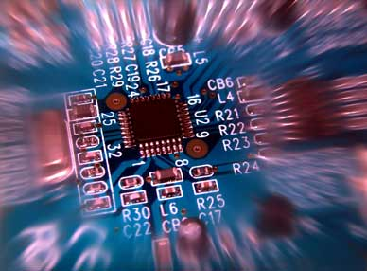
System Design Document
Table of Contents

3. Requirements Traceability Matrix

ID | Functional Requirement | Implementation
T1 | There is one up/down signal per floor. Whenever pressed, the microcontroller responds by sending an elevator to that location with the intention of going in the direction signaled. | Button low level drivers implemented in the McGumps Microprocessor board (See Section 2.2.5). The event is handled in the central processing station via a serial I/O driver (See Section 2.2.4)
T2 | Position feedback is sent by every elevator such that the control system is always aware of all the elevator positions. | Since the elevator is actually virtual, its position will be generated by a sub system of the central processing station, responsible to create, operate and maintain the virtual elevators (See Section 2.2.2). The elevator position feedback is also sent to the GUI which displays it on the monitor (See section 2.2.3). The communication is handled implicitly via a global variable elevator Object accessible by all systems.
T3 | Any given elevator spans all the floors of the building, such that any floor is accessible from all the others. | This is implemented at a low level in the Data Processing unit (see Section 2.2.1) by means of variable boundaries. It is also reflected in the I/O drivers (See Section 2.2.5): there are 20 valid floor buttons which can be pressed by the user), as well as in the GUI (See Section 2.2.3 the virtual building displayed is 20 floors high)
T4 | Each elevator is equipped with a number button board; one button representing one floor. | Implemented by the PS/2 keyboard connected to the McGumps Microprocessor board (See Section 2.2.5)
T5 | Each elevator is equipped with an EMERGENCY button. | Implemented by the PS/2 keyboard connected to the McGumps Microprocessor board (See Section 2.1: System Architecture for Hardware and Section 2.2.5 for software drivers)
T6 | Each elevator is equipped with an OPEN and CLOSE door buttons. | Implemented by the PS/2 keyboard connected to the McGumps Microprocessor board (See Section 2.1: System Architecture for Hardware and Section 2.2.5 for software drivers)
T7 | A certain priority of commands will be maintained in the system. | Implemented in the Data Processing and decision making software component (See Section 2.2.2)
T8 | A 3D visual interface will serve as visual support for the Elevator System. | Implemented in the Graphical User Interface component (see Section 2.2.3)

ID | Error Detection Functional Requirement | Implementation
T1 | Very high speed recovery. | Implemented in the Data Processing and decision making software component (See Section 2.2.2)
T2 | Emergency Timeout | Implemented in the Data Processing and decision making software component (See Section 2.2.2)

