­

**ECSE 421**

**Group #5**

Max Chau   
Ching-Wai Chee   
Simon Foucher   
Jean-Mikael Lassonde   
Winston Lin   
Mathieu Perreault   
Logan Smyth   
Philip Tang   
Danny Wu

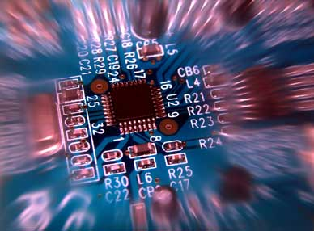

System Design Document

Table of Contents

1. Introduction 3

2. Design Overview 3

2.1. System Architecture 3

2.2. System Operation 4

2.3. Central Processing Station: Application Interface 4

2.3. Central Processing Station: Serial I/O Drivers 4

2.4. McGumps Microprocessor Board: I/O Drivers 4

3. Requirements Matrix 6

# 1. Introduction

This document provides overall guidance of the software project, which consists of an elevator system for a twenty floor apartment building with three elevators. This document outlines how all parts of the software will integrate with the overall system as well as how they will each individually work.

# 2. Design Overview

## 2.1. System Architecture

Figure 1 below depicts the overall system in the form of a deployment diagram. The system will be constructed from the following components:

* **Central Processing Station**

This component monitors the overall elevator system and consists of an ordinary computer. It is the primary graphical and audio interface for the overall system and handles the majority of the elevator logic. Graphics will be shown on the attached ***Monitor***. Inputs specific for the monitoring system will be provided by the attached ***Keyboard*** and ***Mouse***.

* + **Application Interface**

This custom application will be where the bulk of the software work is performed. The graphics will be displayed using standard OpenGL. Sound will be handled using standard system libraries. More information concerning this software component can be found in section 2.3.

* + **Serial I/O Drivers**

This custom driver will interact with the ***Application Interface*** and is required to communicate over the serial line with the ***McGumps Microprocessor Board***. More information concerning this software component can be found in section 2.4.

* **McGumps Microprocessor Board**

This component functions as the controls for the three elevators. Consisting of a MSP430F149 MCU chip and a MAX7128AE PLD, this control system will communicate with the ***Central Processing Station*** via a ***Serial Line***. It will accept the elevator inputs from an attached ***PS/2 Keyboard*** and provide simple graphical output from a directly attached ***Character LCD Display***.

* + **I/O Drivers**

In order to perform its required functions, running on the McGumps board will be numerous input and output drivers. More information concerning this software component can be found in section 2.5.

Central Processing Station

McGumps Microprocessor Board

Application Interface

I/O Drivers

Monitor

Keyboard and Mouse

Serial

PS/2 Keyboard

Character LCD Display

Serial I/O Drivers

Serial

Serial

USB

DVI or VGA

1. Deployment Diagram

## 2.2. System Operation

### 2.3. Central Processing Station: Application Interface

Globals (variables/objects), State/Class diagrams Dataflow diagrams

The following diagram is the basic dataflow of the Application Interface of the central processing Station.



Diagram 3: Central processing station dataflow

### 2.3. Central Processing Station: Serial I/O Drivers

Globals (variables/objects), State/Class diagrams Dataflow diagrams

### 2.4. McGumps Microprocessor Board: I/O Drivers

Globals (variables/objects), State/Class diagrams Dataflow diagrams

The following diagram is the dataflow of the Microprocessor board, which represents the individual elevators.



Diagram 9: Microprocessor Board dataflow

# 3. Requirements Matrix