ECSE 421
Group #5
Max Chau
Ching-Wai Chee
Simon Foucher
Jean-Mikael Lassonde
Winston Lin
Mathieu Perreault
Logan Smyth
Philip Tang
Danny Wu
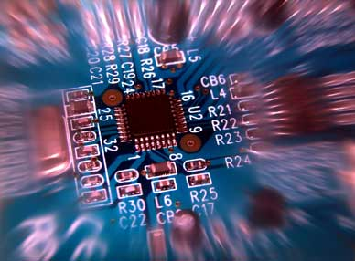
System Design Document
Table of Contents

1. Introduction 3
2. Design Overview 3
2.1. System Architecture 3
2.2. System Operation 4
2.3. Central Processing Station: Application Interface 4
2.3. Central Processing Station: Serial I/O Drivers 4
2.4. McGumps Microprocessor Board: I/O Drivers 4
3. Requirements Matrix 6

1. Introduction

This document provides overall guidance of the software project, which consists of an elevator system for a twenty floor apartment building with three elevators. This document outlines how all parts of the software will integrate with the overall system as well as how they will each individually work.

2. Design Overview

2.1. System Architecture
Figure 1 below depicts the overall system in the form of a deployment diagram. The system will be constructed from the following components:
- Central Processing Station
This component monitors the overall elevator system and consists of an ordinary computer. It is the primary graphical and audio interface for the overall system and handles the majority of the elevator logic. Graphics will be shown on the attached Monitor. Inputs specific for the monitoring system will be provided by the attached Keyboard and Mouse.

  - Application Interface
This custom application will be where the bulk of the software work is performed. The graphics will be displayed using standard OpenGL. Sound will be handled using standard system libraries. More information concerning this software component can be found in section 2.3.

  - Serial I/O Drivers
This custom driver will interact with the Application Interface and is required to communicate over the serial line with the McGumps Microprocessor Board. More information concerning this software component can be found in section 2.4.

- McGumps Microprocessor Board
This component functions as the controls for the three elevators. Consisting of a MSP430F149 MCU chip and a MAX7128AE PLD, this control system will communicate with the Central Processing Station via a Serial Line. It will accept the elevator inputs from an attached PS/2 Keyboard and provide simple graphical output from a directly attached Character LCD Display.

  - I/O Drivers
In order to perform its required functions, running on the McGumps board will be numerous input and output drivers. More information concerning this software component can be found in section 2.5.

Central Processing Station
McGumps Microprocessor Board
Application Interface
I/O Drivers
Monitor
Keyboard and Mouse
Serial
PS/2 Keyboard
Character LCD Display
Serial I/O Drivers
Serial
Serial
USB
DVI or VGA
- Deployment Diagram

2.2. System Operation

2.3. Central Processing Station: Application Interface
Globals (variables/objects), State/Class diagrams Dataflow diagrams

2.3. Central Processing Station: Serial I/O Drivers
Globals (variables/objects), State/Class diagrams Dataflow diagrams

2.4. McGumps Microprocessor Board: I/O Drivers
Globals (variables/objects), State/Class diagrams Dataflow diagrams

3. Requirements Matrix

