Don Force is the CEO of Canachem.
Joe Burke Chief Operating Officer is \
Solomon Binding is an independent director of Canachem and is an experienced corporate director. considered the lead director. chair of the Compensation Committee
Edward Parboyle the Chairman, ,
Frank Masters One of the two independent directors,
VP of Human Resources (unnamed)
(She) Joan McGovern, the Corporate Secretary, who is also general counsel for the company

two other executive directors, other than Don and Joe – the SVP Finance, Prudence Cash,
other Executive Director is the SVP Engineering, Harry Flash.
Harry Flash SVP of Engineering,

Jose Altamirano

Krastyo Komsalov

Security and network infrastructure analyst

Scott Carroll

PhD, PMP, Scientific Project Manager at Algorithme

Scott Carroll

PhD, PMP, Scientific Project Manager at Algorithme

Associate Contract/Quality Officer at ICAO
Montreal, Canada Area
Airlines/Aviation

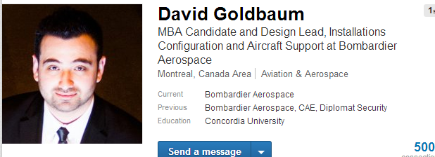

Simin Seifzadeh

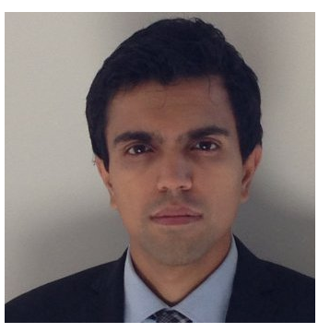

Yasir Siddiqui

Cofounder at Hardware Guild

Genevieve Lavigueure

