Project Report
MBA 695O: Corporate Governance Instructor: Janis Riven
August 14th, 2014

Geneviève Lavigueur – #6769780
Golnaz Ashtiani - #5085896
Simin Seifzadeh - #6582419
Simon Foucher – #7107722

TABLE OF CONTENTS

Executive Summary 4
About the company 5
Air Canada Express 5
Air Canada Rouge 5
Air Canada Cargo 5
Air Canada Vacations 5
Corporate Governance 7
Shareholder relations 7
Auditors 7
Board 7
Compensation 8
Shareholders 8
Dual Class Shares 8
Fairly identical in terms of pricing 9
But there is a spread between the two classes 9
Compensation 10
Risk Management 11
Corporate Social Responsibility (CSR) 12
Financials 14
Recommendations 18
References 19
Appendices 20

Executive Summary

About the company
Founded in 1936¹, Air Canada is the largest Airline of the market in Canada. It was named Trans-Canada Airline, but in 1965, it was renamed for Air Canada. They have four hubs located in Canada: Toronto, Vancouver, Montréal and Calgary that provided, in 2013, a total daily average of 1498 schedule flights traveling to a total of 181 destinations worldwide. In 2013, they had respectively 326, 144, 134 and 105 daily departures. Also, they traveled a total of 35.8 millions passengers.
Air Canada has four divisions: Air Canada Express, Air Canada Rouge, Air Canada Cargo and Air Canada Vacations.

Air Canada Express
Air Canada Express is the brand name for traveling passengers through independent airlines including Jazz Aviation, Sky Regional Airlines, Exploits Valley Air Services and Air Georgian.

Air Canada Rouge
Air Canada Rouge mostly covers destinations to Europe, the Caribbean, Mexico and United States. This division is considered a budget airline and focuses on improving margins on leisure routes. Their target is to continue to develop the international leisure markets in the coming years.

Air Canada Cargo
Air Canada Cargo division provides cargo services traveling to more than 150 destinations worldwide through Air Canada Airlines and its partners.

Air Canada Vacations
Air Canada Vacations offers leisure complete travel packages including tours, cruises and vacations, with everything included such as accommodation, car rentals, round-trip, etc.

Air Canada is a member of Star Alliance network that includes twenty-eight airline members. Moreover, they offer a loyalty program offering Aeroplan miles to loyal Air Canada and Star Alliance customers. Based on the customers’ Aeroplan’s level, Air Canada offers benefits and privileges to loyal customers based on their number of miles. Aeroplan is the largest customer of Air Canada.
Air Canada has four key elements to succeed in the airline market: cost transformation and revenue improvement, international growth, customer engagement and culture change.

Corporate Governance

Shareholder relations
- Air Canada Headquarter is located at Trudeau International Airport, a place far from downtown and not easily accessible via public transportation. Shareholder meeting held at ICAO office on University Street, in the core of downtown to accommodate shareholders.
- Proxy voting made possible by mail, fax, and via internet

Auditors
- PWC LLP has been Auditor for AC since April 1990 – best practice suggest to switch auditors from time to time to insure auditor neutrality and avoid friendships being built between the auditors and auditees, which could potentially result in conflicts of interests.

Board
- Recently adopted majority-voting policy, if more withheld than “for”, board member expected to offer his resignation to the Chairman. The Governance and Corporate Matters committee will analyze the situation and the committee will make a recommendation for the board to accept it or not.
- Articles permit from 7 to 21 directors, currently have 9; good number.
- 10 meeting per year = goof meeting frequency; not minimalistic board
- Average tenure of directors is 4.6 years; with roughly 1/4 directors with <2 years tenure.
- 8 independent on 9 members = good independence. Only non independent director is <r. Rovinescu, the CEO
- There is a retirement policy, age 75, but the board can choose not to apply the limit and extend a director term passed the maximum age
- Almost perfect attendance; only 1 director missed one meeting last year.
- Directors are encouraged to follow continuous education, and their attendance to training is disclosed in the proxy
- Directors are chosen by a nomination committee with guidelines for nomination
- Formally discusses and reviews succession planning of all executives

Compensation
- Industry study performed to increase compensation according to peers included in the review
- Variable compensation to align behavior with strategy
- Clawback policy in place (adopted in 2011)
- Clear disclosure of compensation granted, accomplishements and targets used for executives

Shareholders
- Only disclosed significant Shareholder is Letko with 18.49% ownership of class B voting Shares (Canadian)

Dual Class Shares
- Class A and Class B have identical terms except that Class A – variable voting shares, have voting limitations for foreign owners
- Implemented to comply with the Air Canada Public Participation Act (ACPPA) and Canada Transportation Act (CTA)
  - CTA requires that 75% of voting rights of licensed Canadian Carriers be owned by Canadians.
  - ACPPA has a section that limits the voting interest of non-Canadian to 25%
- Investors can’t choose to buy A or B Shares, they are available as a function of weather the acquirer is Canadian (Class b), or a foreigners (Class A); a Canadian purchasing a Class A share will effectively convert it to a Class B and a foreigners purchasing a Class B will convert it into A
- The main difference is that for Class A variable voting shares, one share provides one vote unless ownership of Class A shares exceeds 25% or that there are more than 25% of Class A shares that exercise a vote, in which case the weight of the Class A shares vote will be scales to 25% and the weight of Class B shares increased accordingly

Fairly identical in terms of pricing
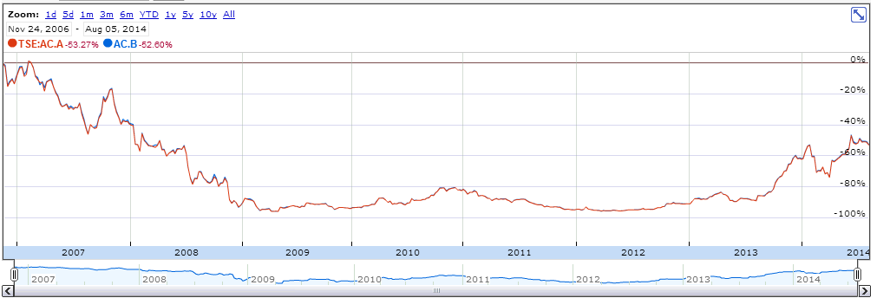

But there is a spread between the two classes
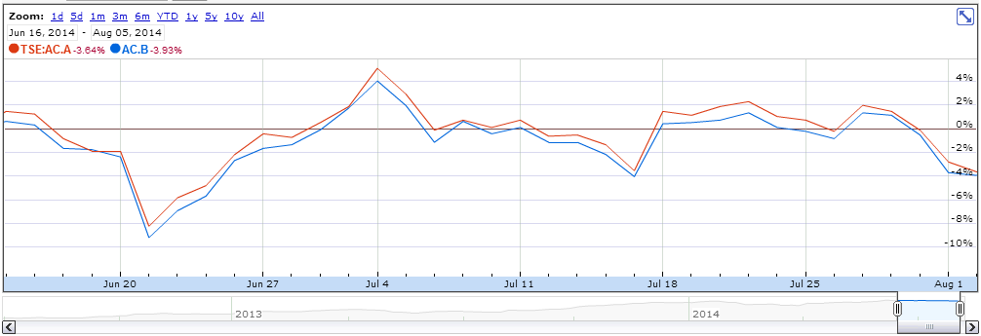

Most likely, as soon as the spread becomes significant enough to generate a profit after commission and overheads, a Canadian based arbiter performs a transaction to close the gap.
Interesting to observer that Class A, although prices similarly to Class B, are almost always priced higher, demonstrating that there is more investment appetite available abroad than within Canada.

Compensation
- The CEO was offered in 2012 a 5M$ retention bonus. This bonus was not tied to any performance KPIs but rather an unconditional sign up bonus to be paid out if he remained employed for at least 3 years. Although the practice is legal, the verbiage used in the 2013 Proxy to disclose this bonus raises questions in terms of accountability of the board, more specifically the statements: "The recruitment of top corporate executives, including the CEO, is very competitive. [...] the Board of Directors was advised by an independent third-party consulting firm as to the terms of his compensation"

Risk Management
Dual Class Share – (enforced by ACPPA and CTA) ensure that voting interests is held in majority by Canadians -> Most likely have the best interest of important local issues like safety and environment. Ensures that company is not controlled by foreigner primarily concerned with margins who could potentially cut on safety/environment without material attachments to the social cots of potential accidents (ex: Like MMA in railroads)

Corporate Social Responsibility (CSR)
Air Canada’s corporate sustainability report has been first issued in 2011 and the latest issue, Citizens of the World was issued covering year of 2012, approved by corporate governance’s committee and is focusing on four main areas of sustainability defined based on internal and external surveys: safety, the environment, employees and community. The report is covering many initiatives in each of the four areas supporting the CSR goals; however, it is not addressing some of the issues and lacks a more thorough explanation about some of their initiatives.
With regards to safety, procedures are in place to ensure nigh safety standards, however, many of the initiatives are undertaken in order to comply with the minimum requirements set by regulations or to maintain registration to recognized organizations like IATA. Only one third of employees participated in Safety Pulse Survey which is a very low rate. No information has been provided to address this low participation rate which could be a sign of employee dissatisfaction.
With regards to the impact on the environment, many initiatives are listed under CO2 reduction, which are primarily focusing on reaching economies of scale, achieving efficiency, cutting cost and lowering fuel consumption, the Air Canada’s largest expense. There have been only two revenue flights suing biofuel operated in 2012 by Air Canada.
About 90% of the employees are unionized which can explain the average age of 44 for workforce. Air Canada’ union environment creates challenges to motivate and empower employees based on results and performance. Labor troubles and pension obligations resulted in problems with unions and consequently considerable cost. After instances of many strikes and lockouts, unhappy employees were banned from strikes by legislation but this could only result in other actions by employees to show their dissatisfaction where 75 flights were cancelled when dozens of pilots called in sick in 2012.
It is mentioned in the CSR report 2012 that in order to support its foundation to improve delivery of charitable initiatives, Air Canada planned to establish an employee payroll deduction plan in 2013. Detailed information is not provided about the implementation plan and employees’ consent to absorb the cost and it seems to be a cost pushed to the employees.
In March 2012, Aveos Fleet Performance Inc. Air Canada’s subcontractor went out of business, following a decline in business from Air Canada who gave a 5 year renewable contract to AAR, an American company that would maintain its airplanes with 350 workers, putting 2,600 people out of work in Manitoba, Ontario and Quebec. From cost reduction perspective, it is justifiable to outsource support services abroad to countries that can carry the work cheaper and more efficient however these initiatives demonstrates lack of support for local society and economy.
It is mentioned in Air Canada’s 2013 Management’s Discussion and Analysis of Results of Operations and Financial Condition that as part of Air Canada’s initiative to reduce cost and increase efficiency and competitiveness, new high density Boeing 777 has been introduced into Air Canada’s fleet to increase the number of seats from 458 to 349. This initiative has a positive impact in reducing fuel consumption and consequently CO2 emission per passenger per flight, however, the main incentive is to increase Air Canada’s profit. This saving on cost is not being translated into price reduction and hence customers eventually bearing the cost for their decreased comfort level.
Air Canada rouge has been launched on July 2013 to enhance margins on leisure routes through its competitive cost structure, however, one of the main elements that enables lower cost operation is lower wages which shifts the costs to employees.

Financials
- Since IPO back in 2007, the share price has significantly decreased. The pronounced decrease in 2007 can potentially be attributable to the spike in oil process, and the 2008 decent attributable to the global recession
- 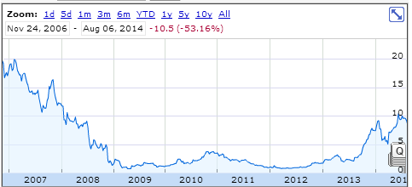
- Following this decline, the CEO was replaced with the current CEO, Calin Rovinescu, was appointed in Q2 2009, and has experience having been AC’s Chief Restructuring Officer following the bankruptcy protection
- Since his applintement // appointement ?, the stock has been keeping at par with competitors, until mid 2013 when it posted it’s first profitable earning statement since 2007 and started to significantly over perform its commercial rivals.

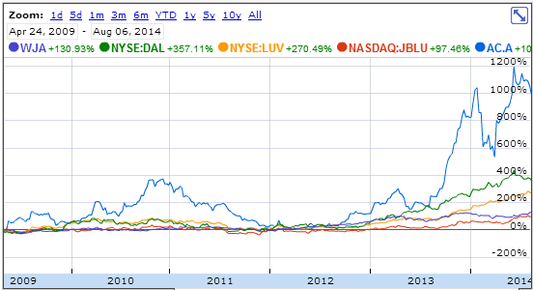
- Company is posting slow revenue growth. Although operating income has been positive since 2010, the Government had passed the Air Canada Pension Plan Funding Regulations in 2009, requiring the company to make significant contributions to defined benefit pension plans. The company came to an agreement with the GoC to fund the pension plan until 2020; the company will have to make payments of at least 150M$ into the fund, with an average of 200m$ annually in order to provide an aggregated 1.4B$ into the fund. Additionally, restrictions have been put in place for executive compensations.

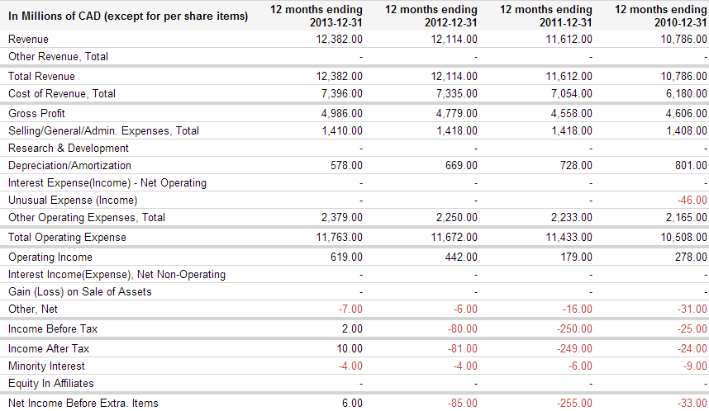
- Although currently profitable, the company still has an accumulated deficit of 2.3B$, and might have unproperly??? quantified liabilities towards pension funds
- Fuel prices are on the rise, and with more internet based meeting technologies, the future of airlines remains uncertain
- Since 2007, Air Canada has been significantly underperforming compared to most peers in the airlines industry. The following data was taken from Google finance:
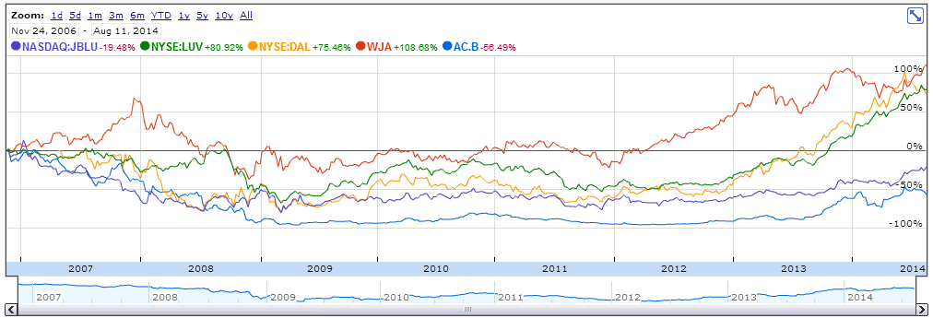

- Current CEO was appointed in

Recommendations
- Auditors
- Pension Plans

References

Appendices

http://www.aircanada.com/en/about/corp_sustainability.html
http://www.theglobeandmail.com/report-on-business/air-canada-must-cleanse-poisonous-culture-expert-warns/article4239400/
http://www.cbc.ca/news/business/air-canada-to-appeal-quebec-court-ruling-on-aveos-1.1402818

